Genesis Innovation Academy (GIA) Governance Committee – 20 April 2021

- OPENING/CALL TO ORDER

- ATTENDANCE

- ANNOUNCEMENTS & RECOGNITION

- AGENDA/DISCUSSION ITEMS:
  - Board Development
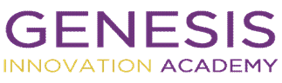
  - Board Operations
  - Strategic Planning

- PUBLIC FORUM

- RECOMMENDATIONS/MOTIONS to BOARD (if any):

- EXECUTIVE SESSION (if necessary)

- ACTION ITEMS:

- NEXT MEETING: May 18, 2022, 5:00pm

- CLOSING/ADJOURN

